Holy Spirit  Christian Nursery School  Curriculum | 
The curriculum for Holy Spirit Christian Nursery School establishes goals to foster growth at the appropriate developmental level. In each classroom, our staff nurtures the development of skills and abilities across the stages of development. Children begin growing and developing in the social, physical and academic area in the Threes classes but continue growing within each area throughout nursery school.

First School Experience
Three-Year-Olds: Tadpoles and Pollywogs

In the Three-Year-Old class (2 and 3 sessions/week), children experience a time away from parents and home. They have the opportunity for independent and group play, small group learning, and whole group activities.

Social/Interpersonal - Ability to:  - Separate from Mom/Dad  - Play cooperatively  - Follow simple directions  - Communicate wants and needs  - Recognize and label basic feelings  Three-Year-Olds continued…  Literacy – Ability to:  - Identify book front cover and turn book pages  - Identify rhyming words  - Recognize own name  - Talk to friends/teacher  - Listen to friends/teacher  - Listen to a story and respond to it  - Identify colors | Mathematics – Ability to:  - Recognize simple shapes and patterns  - Categorize items  - Count (1-10)  - Count 5 objects with one-to-one correspondence  - Use language to compare objects (bigger than, smaller than) and describe position (over, under, first, second)  Other – Develop gross  and fine motor skills

Getting Ready for Kindergarten  Four and Five-Year-Olds:  Cubs… Panda Bears  & Brown Bears | 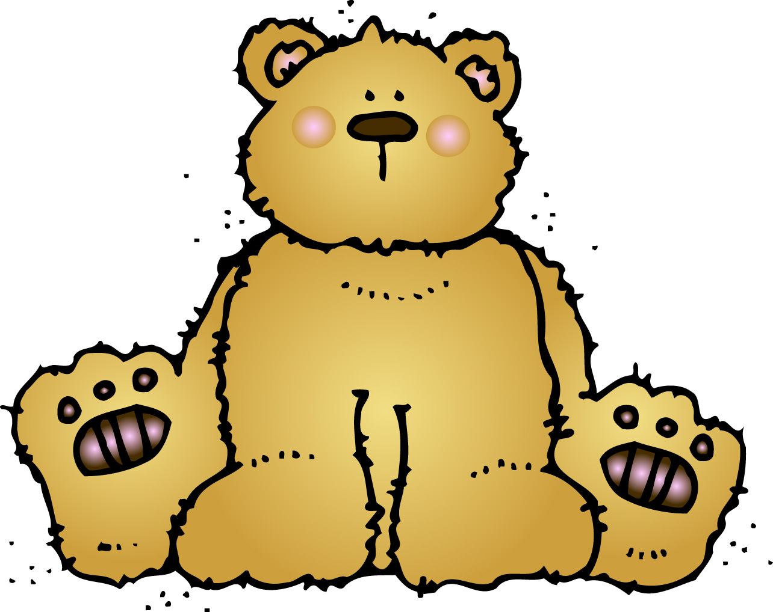
The Panda Bears (4 sessions/week) and the Brown Bears (3 sessions/week) experience play, group activities, and small and whole group learning. Children learn through play, stories, songs and activities. Early literacy and mathematics skills are intertwined within the activities and play. At the end of this experience, some children will move into kindergarten, and some will attend another year of nursery school.

Social/Interpersonal – Ability to:  - Be a friend  - Play cooperatively  - Attempts new activities  - Work well with others  - Be part of a classroom community  - Participate in group discussion  - Follow simple directions  - Communicates wants and needs  Literacy – Ability to:  - Talk and listen to friends/teacher  - Identify and make up words that rhyme  - Listen to a book and respond to it  - Identify letters and letter sounds  - Write own name  - Retell a story in sequence  - Clap syllables | Mathematics – Ability to:  - Recognize numbers (1-21)  - Count (1-20)  - Categorize items  - Recognize and create simple patterns  - Identify shapes  - Count ten objects with one-to-one correspondence  Other Areas  - Develop gross motor skills  - Develop fine motor skills…cut, draw simple shapes, hold pencil correctly

Cubs… Polar Bears | 
The Polar Bear Classes (4 sessions/week) is designed children who are five or almost five years old, children whose parents choose an extra year of pre-school or whose birthday just misses the school cut-off. They experience time to learn and/or enrich early literacy and mathematics skills while expanding friendship and social skills within a small classroom community.

Social/Interpersonal - Ability to:  - Be a friend  - Play cooperatively  - Work well with others  - Be part of a classroom community  - Participate in group discussion  - Follow directions  - Communicates wants and needs  - Attempt new activities  - Independently manage personal items  Literacy – Ability to:  - Talk and listen to friends/teacher  - Identify and make up words that rhyme  - Listen to a book, make connections and respond to it  - Retell stories  - Claps syllables  - Identify letters and letter sounds  - Writes own name  - Recognize familiar words and environmental print  - Represent experiences through developmentally appropriate writing | Mathematics – Ability to:  - Recognize numbers (1-20)  - Categorize items by attribute  - Recognize and create simple patterns  - Count (1-20)  - Recognize and reproduce simple geometric shapes  - Participate in group problem solving  - Add sets of objects up to five  - Compare two sets with up to 10 objects  Other Areas –  - Develop and refine gross motor skills  - Develop/refine fine motor skills…cut, draw simple shapes, hold pencil correctly

 | Busy Beavers  (Planned for children who are Age 4 by the first session)

On Fridays, the Busy Beavers enrich their week-long learning. Besides making new friends, children will have more time to play, explore and create through fantasy, science, and social studies themes. (Knights, dragons, princesses, engineering/science projects, building, painting, cooking, reading/writing, and drama name a few.)


Playful Penguins (Age 3-5 years)

On Tuesday and Wednesday, we invite the children to pack a lunch and stay for an afternoon of extended play time. A variety of creative play and learning experiences will be offered. Past themes have included Community Helpers, Robots, Ice, Paint Your Heart Out and Let’s Get Building. (Several six-week sessions will be offered. A minimum number of children are required to offer the class.)

